**Project Title:**

To perform classification analysis on Iris dataset.

**Project Details:**

In this project ,we have to classify the Iris data set based on the features named sepal-size, sepal-width ,petal-size and petal-width and provide the results whether given data belongs to iris-setosa class or iris-versicolor class or iris-verginca class .

In this project , classification is based on three classes, so I have chosen support vector Machine Algorithm to classify the dataset.

**Tools Used :**

Google colab ,Iris dataset ,Machine Learning Algorithms.

**Algorithm used:**

Support Vector Machine:

* Support Vector Machine or SVM is one of the most popular supervised Learning Algorithms ,which is used for classification as well as Regression problems .However, primarily it is used for classification problems in machine learning .
* The goal of the SVM algorithm is to create the best line or decision boundary that can segregate n-dimensional space into classes so that we can easily put the new data point in the correct category in the future. This best decision boundary is called a hyperplane.
* SVM chooses the extreme points/vectors that help in creating the hyperplane. These extreme cases are called as support vectors, and hence algorithm is termed as Support Vector Machine.

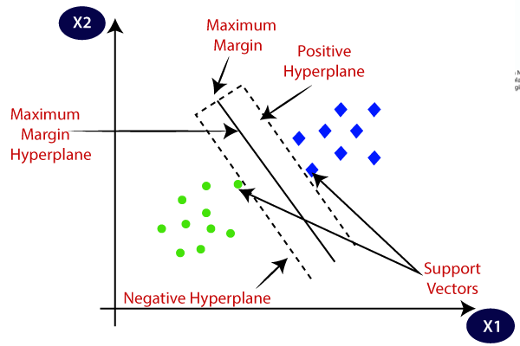

**Support Vector Machine**

**Explanation :**

* In this project, initially load the dataset into google collab ,then split the data into train and test datasets .
* After getting the train and test data sets seperately , train the SVM model using the train data set.
* Now, predict the results to which class the data will belongs to, using test datasets.
* Compare the results that are predicted by model using test data set and actual result.
* This can be known by using the confusion matrix and accuarcy score.
* **Accuracy score** : the set of labels predicted for a sample must exactly match the corresponding set of labels in y_test.
* **Confusion Matrix:** A confusion matrix is a table that is often used to describe the performance of a classification model (or "classifier") on a set of test data for which the true values are known.
* Svc has kernel attributes which is of two types.
* Initially use kernel as “linear “ and find the accuracy.
* Then use kernel as “rbf” and find the accuracy.
* Thus we came to know the accuracy of the model by using the iris dataset.